
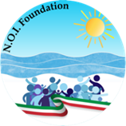

The Consulate of Italy in Detroit,
Education Office in collaboration with
Ente N.O.I. Foundation, is proud to present:
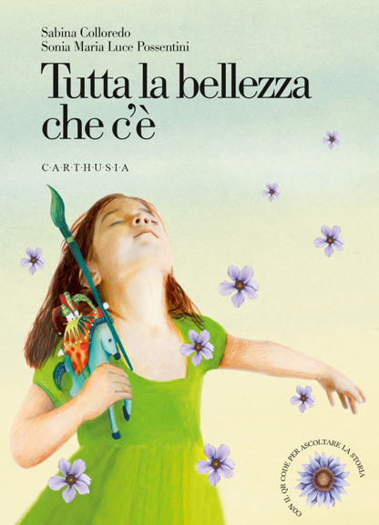

Lettura espressiva in italiano

The timeless and evocative ballad, Tutta la bellezza che c’è, by the beloved author of Italian children’s literature Sabina Colloredo, describes through inspiring poetry and lovely illustrations the beauty of Italy and its culture.

Sabina lived in Milan, Italy, she has published over one hundred books including picture books, novels, biographies, and poetry, which have been translated into many languages and enjoyed by her readers all over the world.

For the School:

Bishop Watterson High School, Columbus OH

Wednesday, 5-13-2026

